## **Monday- Pajama Day!**

## 

## **Tuesday- Meme or Emoji Day!**

# 

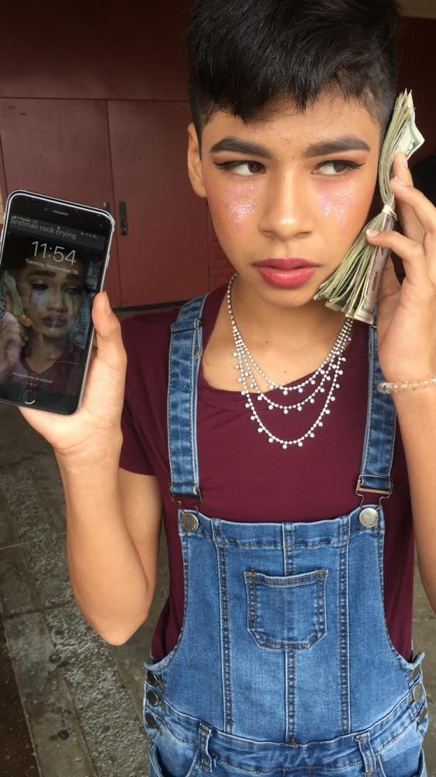

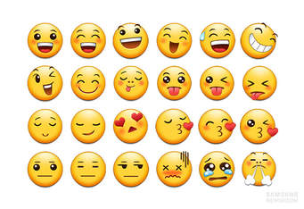

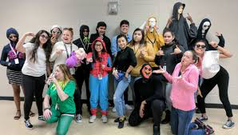

## 

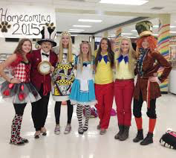

## **Wednesday- Costume Day!**

## 



## **Thursday- Inside-Out Day!**

## 

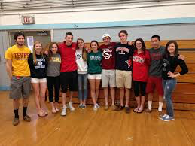

## **Friday- Spirit and College Wear!**